**Session 17: Assignment 1**

**Problem Statement 1:**

Blood glucose levels for obese patients have a mean of 100 with a standard deviation of

15. A researcher thinks that a diet high in raw cornstarch will have a positive effect on

blood glucose levels. A sample of 36 patients who have tried the raw cornstarch diet

have a mean glucose level of 108. Test the hypothesis that the raw cornstarch had an

effect or not.

**Code:**

The population mean is 100.

Standard Deviation is 15

Assume significant level 5% ( 0.05 )

Probablity using z score/ z table = (108 -100) / (15/ sqrt(36))

import math

import scipy.stats as st

#Population Mean

m =100

#Glucose level (x)

x=108

#Standard Deviation (s)

s=15

#Number of Samples

y=36

#z= ((x-mean)/ (Standard Deviation/square root of (Number of Samples)))

z= (108-100)/(15/math.sqrt(36))

display(z)

st.norm.cdf(z)

**Result : Probablity of having value less than mean Glucose level ( 108) is 0.9993128620620841 & more than or Equal to 108 is ( 1-0.9993128620620841) = 0.0006871379379159 , which is less than 0.05 so we will reject the Null hypothesis.**

**Output:**

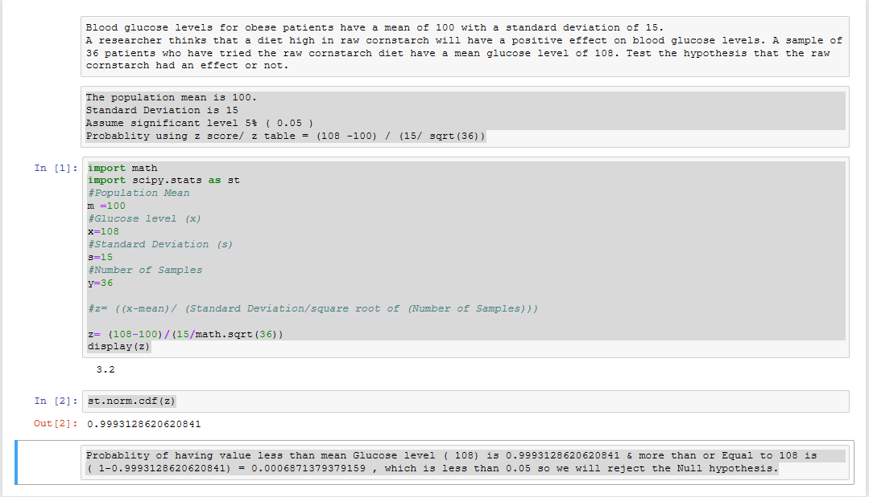

**Problem Statement 2:**

In one state, 52% of the voters are Republicans, and 48% are Democrats. In a second

state, 47% of the voters are Republicans, and 53% are Democrats. Suppose a simple

random sample of 100 voters are surveyed from each state.

What is the probability that the survey will show a greater percentage of Republican

voters in the second state than in the first state?

**Code:**

#### Find the z-score

import math

import scipy.stats as st

# For State 1 Republican Voters 52%. Let it denote with P1

P1 = 0.52

# For Stare 2 Republican Voters 48% . Let it denote with P2

P2 = 0.47

# The number of voters sampled from the first state (n1) = 100,

# The number of voters sampled from the second state (n2) = 100.

n1 = 100

n2 = 100

n1P1 = n1 * P1

display(n1P1)

# n1 and negative of P1 = n1(1 - P1)

n1negP1 = n1 * (1 - P1)

display(n1negP1)

n2P2 = n2 * P2

display(n2P2)

#n2 and negative of P2 = n2(1 - P2)

n2negP2 = n2 * (1 - P2)

display(n2negP2

# Find the mean of the difference in sample proportions: E(p1 - p2) => Ep1p2 = P1 - P2 = 0.52 - 0.47 = 0.05.

Ep1p2 = P1 - P2

display(Ep1p2)

stdValues = (P1 * (1 - P1) / n1) + ( P2 * (1 - P2) / n2 )

display(stdValues)

# Standard Deviation σd = stdDeviation

stdDeviation = math.sqrt(stdValues)

display(stdDeviation)

# Transformation appears below.

x = 0

# zp = zp1 - p2 = (x - μp1 - p2) / σd = = (0 - 0.05)/0.0706 = -0.7082

zp = (x - Ep1p2) / stdDeviation

display(zp)

# Using Normal Distribution Calculator, we find P(z <=0.7082) = 0.24 the probability of a z-score being -0.7082

#or less is 0.24

st.norm.cdf(zp)

**Output:**

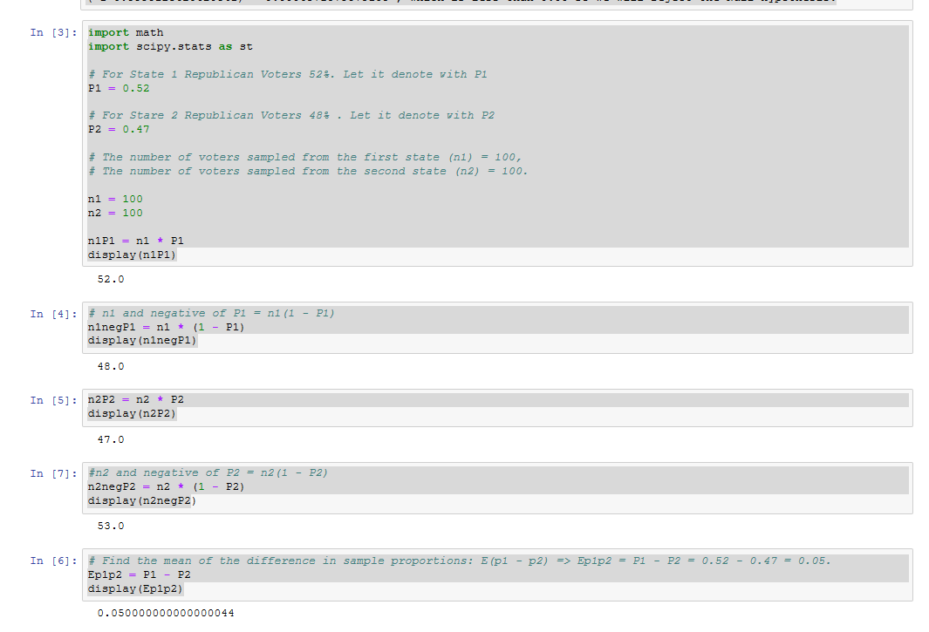

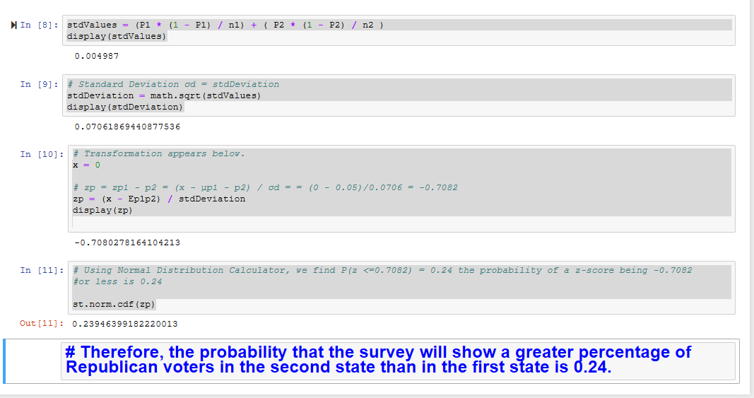

**Problem Statement 3:**

You take the SAT and score 1100. The mean score for the SAT is 1026 and the standard

deviation is 209. How well did you score on the test compared to the average test taker?

**Code:**

import math

import scipy.stats as st

# SAT Total Score x

x = 1100

# Mean score μ let we do it as m

m = 1026

# Standard Deviation σ and let we do it as s

s = 209

# z = (x - μ) / σ

z = (x - m) / s

display(z)

st.norm.cdf(z)

**Output:**

